**A**

**Project Report on**

**Faculty Assistant using R.P.A**

**By**

**Raghav Gupta**

**Umang Bhan**

**Vastvik Upadhaya**

**Samarkant Bhasin**

**Sahil Singh**



**DEPARTMENT OF**

**COMPUTER SCIENCE & ENGINEERING**

**Model Institute of Engineering & Technology**

**A**

**Project Report on**

**Faculty Assistant Using R.P.A**

**In partial fulfillment of requirements for the degree of**

Bachelor of Engineering

In

Computer Science & Engineering

**SUBMITTED BY:**

**Raghav Gupta**

**Umang Bhan**

**Vastvik Upadhaya**

**Samarkant Bhasin**

**Sahil Singh**

**Under the Guidance of**

Prof. Ankur Gupta

Asst. Prof. Anand Kumar



**DEPARTMENT**

**OF**

**COMPUTER SCIENCE & ENGINEERING**

Model Institute of Engineering & Technology – Jammu

Model Institute of Engineering & Technology – Jammu

**CERTIFICATE**

Certified that minor project work entitled “**FACULTY ASSISTANT USING RPA”** is a bonafide work carried out in the 7th semester by “**Umang Bhan, Raghav Gupta, Samarkant Bhasin, Vastvik Upadhaya, Sahil Singh**” in partial fulfillment for the award of Bachelor of Engineering in Computer Science Engineering from Model Institute of Engineering & Technology during the academic year 2020-2021.

**Project Guide**

Prof. Ankur Gupta

Asst. Prof. Anand Kumar

**ACKNOWLEDGEMENT**

The accomplishment of this Minor Project report on “Faculty Assistant using R.P.A” benefits of the guidance, moral support and encouragement bestowed on us throughout our work period. For this, we wish to express our sincere gratitude and appreciation to all those who gave us the possibility to complete this report. We would like to acknowledge with much appreciation, the crucial role of the faculty of CSE department of MIET, Jammu, who gave us permission to use all the resources and material required to complete my report. We cannot express enough thanks to Prof. Ankur Gupta and Asst. Prof. Anand Kumar for their continued support and encouragement to work on our own and discover new things in this field. Lastly, we must offer our sincere appreciation for the receipt of affectionate care and opportunities to Model Institute of Engineering and Technology (MIET) for providing us with such a wonderful work environment. Our accomplishment of this report could not have been possible without the support of our classmates and our family, who provided us with love, support and encouragement when times got rough.

Umang Bhan

Raghav Gupta

Samarkant Bhasin

Vastvik Upadhaya

Sahil Singh

CSE MIET

**TABLE OF CONTENTS**

**Topic Page No.**

ABSTRACT……………………………………………………………….8

1. INTRODUCTION………………………………………………………9

1.1. BACKGROUND AND OBSERVATION

1.2. OBJECTIVE AND NEED

2. ROBOTIC PROCESS AUTOMATION…………….………………....11

2.1 INTRODUCTION

2.2 RPA IMPLEMENTATION METHODOLOGY

2.3 AREAS RIPE FOR AUTOMATION

3. ROBOTIC PROCESS AUTOMATION TOOLS ….………………15

3.1 AUTOMATION ANYWHERE

3.2 UIPATH

3.3 BLUEPRISM

3.4 WORK FUSION

4. VALUE IN RPA……………..…………19

4.1. CUSTOMER SATISFACTION

4.2. PRODUCTIVITY

4.3. ACCURACY

4.4. RETURN ON INVESTMENT

5. UIPATH…………………………………20

5.1. UIPATH STUDIO

5.2. UIPATH ROBOT

5.3. UIPATH ORCHESTRATOR

6. RPA EMAIL AUTOMATION…………………………………………24

7. ARCHITECTURE OF THE SYSTEM……………………….28

8. INTERACTION MODEL………………………….29

9. RESULTS………………………………………………………...30

10. REFRENCES…………………………………………………………...

**TABLE OF FIGURES**

**Figure Page No**

Figure 1- RPA INTRODUCTION-1 12

Figure 2- RPA INTRODUCTION-2 12

Figure 3- RPA Methodology 13

Figure 4- Areas ripe for RPA 15

Figure 5- Automation Anywhere 16

19

Figure 6-Uipath 17

Figure 7- Blueprism 18

Figure 8- Workfusion 19

Figure 9- UiPath Studio 23

Figure 10- Email Automation-1 24

Figure 11 - Email Automation-2 24

Figure 12- Email Automation-3 25

Figure 13- Email Automation-4 26

Figure 14- Email Automation-5 26

Figure 15- Email Automation-6 27

Figure 16 - Email Automation-7 27

Figure 17- Architecture Diagram 28

Figure 18- Interaction Model 29

Figure 19- Results-1 30

Figure 20- Results-2 30

Figure 21- Results-3 31

Figure 22- Results-4 31

Figure 23- Results-5 32

Figure 24- Results-6 32

**ABSTRACT**

During this covid-19 period, the education department has suffered a lot as all the schools and colleges were closed due to the fear of the pandemic. But education is a necessary part of our life, henceforth some way has to be found to tackle the problem. The best way of tackling the problem is using the online classes for teaching and google classroom etc., as a way for assignments. However, the teachers are equipped with a lot of work and in addition to that they also have to look for other things such as taking note of the courses done by students, whether students have applied for jobs etc. So, to solve this problem we have designed an RPA bot that will act as a faculty assistant to teachers.

**INTRODUCTION**

* 1. **BACKGROUND AND OBSERVATION**

During the pandemic, the education department has suffered a lot as all the schools and colleges were closed due to the fear of the pandemic. But education is a necessary part of our life, henceforth some way has to be found to tackle the problem. The best way of tackling the problem is using the online classes for teaching and google classroom etc., as a way for assignments. However, the teachers are equipped with a lot of work and in addition to that, they also have to look for other things such as taking note of the courses done by students, whether students have applied for jobs etc. All the teachers are not equipped with the knowledge of dealing with the online stuff. Also, there is a possibility of forgetting to check for defaulters in time. Apart from this, there is a major problem of time consumption that is wasting teacher’s precious time on this file checking and then mailing each defaulter every time, again and again to remind him of his work. So, what if we have an R.PA bot capable of doing user-scheduled checking of the Project Course completion from the google sheets and also sending emails to the students who have not completed the given course until that day. An email also dropping to the user to tell him about the students who have incomplete course. On-spot checking of the Project Course completion from the google sheets and sending the emails as above. User-scheduled as well as on-spot checking of the submission of ppt and synopsis by the students and again sending the respective emails to the students and the faculty.

* 1. **OBJECTIVE AND NEED**

Faculty Assistant is RPA based online bot which will provide the faculty with various options from checking the status of submission of student synopsis and ppts to the option of checking for the completion status of courses allotted to students according to the google sheet. It will also give the faculty members the flexibility to set the running period of the bot. Furthermore, various charts and graphs will also be displayed in the website showing the progress of students.

**OBJECTIVES:**

* **Scheduled system of sending emails or other stuff on the command of user.**
* **Reducing time, cost and expenditures.**
* **Efficient planning and shift management.**
* **Help in various stuff such as in case of relaying information to students about their progress in respective courses.**
* **Furthermore, checking for items such as synopsis and ppts if the students have uploaded any.**

**ROBOTIC PROCESS AUTOMATION**

**INTRODUCTION**

Through the years, your customer-service operation has become more and more powerful, with advanced functionality provided by increasingly digital tools. That’s clearly a good thing, but it also means that your customer-service team is spending a lot of time. moving from one application to another, filling in the same information in multiple places, reentering data, or copying and pasting. Studies have shown a typical customer contact might require your representative to interact with half a dozen different applications. Your agent can get a lot of important tasks accomplished with the help of those applications, but it’s anything but simple. At the very least, all those manual processes are a recipe for inefficiency. Dealing with them is a source of boredom and dissatisfaction for employees. And it’s a situation that’s ripe for errors. So, why send a human to do a robot’s job? Why waste a good human mind on mind-numbing work that requires little or no analysis and no subjective judgment? Robotic process automation (RPA) uses the latest software technologies to automatically handle computer tasks that are highly structured, routine, and repetitive. For tasks that are largely driven by rules, schedules, or events, a robot can take the wheel and get the job done. Typical back office employees, in fact, spend up to 80 percent of their day on such mundane activities. These workers are filling in forms, making repetitive calculations, and processing orders — all things that are vital for customer satisfaction but tedious for employees. RPA hands such processes off to a robotic workforce. This workforce is precise and accurate and immune to boredom. It can also be scaled vastly more easily than a human workforce. RPA can perform just about any complex rule-based work and can do so through interaction with any software application or website. It’s a robotic connection to the human world of the computer user interface. Just what kinds of desktop activities can be automated? You name it. If a human can do it, a robot can in virtually the same way. Check out the possibilities in Figure. RPA isn’t a replacement for the human customer-service workforce. It’s ideal for tasks that require no human intervention — tasks that are often referred to as unattended. Plenty of tasks require a human connection, but in many cases at least a portion of the work can also be automated through RPA — such tasks are known as attended tasks. Most important, there are many other high-value activities that need your employees’ brainpower, and that happen to be a whole lot more interesting for them. RPA lets software robots optimize your business processes, leaving the humans more bandwidth for the high-value needs.

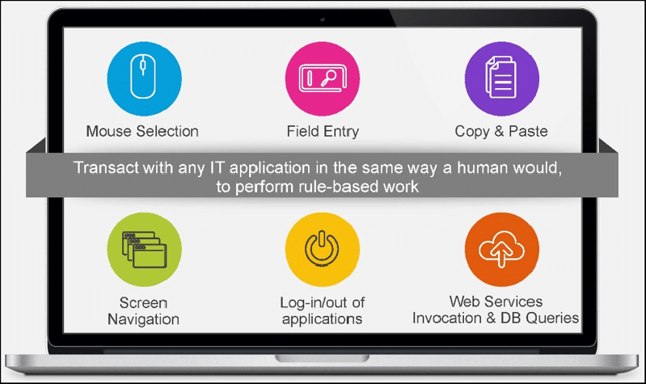

Check the below figure for insights into how RPA fits into your operation.

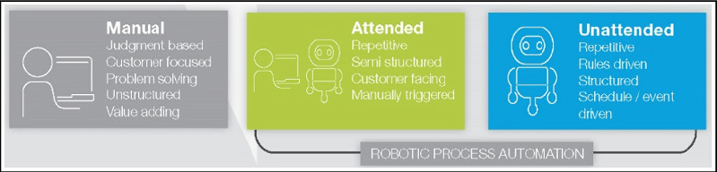

Here, are some reasons why Robotics Process Automation is advantageous

* A human can work average 8 hours a day whereas robots can work 24hours without any tiredness.
* The average productivity of human is 60% with few errors as compared to Robot's productivity which is 100% without any errors.
* Robots handle multiple tasks very well compared to a human being

**RPA Implementation Methodology**

Figure - RPA Methodology

### **Planning**

In this phase, you need to Identify processes which you want to automate. Following checklist will help you identify the correct process

* Is the process manual & repetitive?
* Is the process Rule-based?
* Is the input data is in electronic format and is readable?
* Can existing System be used as it is with no change?

Next, steps in planning phase are

* Setup project team, finalize implementation timelines and approach.
* Agree on solution design for performing RPA processes.
* Identify logging mechanism that should be implemented to find issues with running bots.
* Clear roadmap should be defined to scale up RPA implementation

### **Development**

In this phase, you start developing the automation workflows as per agreed plan. Being wizard driven, the implementation is quick

### **Testing**

In this phase, you run Testing cycles for in-scope automation to identify and correct defects

### **Support & Maintenance**

Provide continuous support after going live and helps in immediate defect resolution. Follow general maintenance guidelines with roles and responsibilities with business and IT support teams.

**Areas Ripe for Automation:**

RPA can help just about every vertical in your organization improve efficiency while also helping both customers and employees feel more satisfied. What’s not to like? The back office and the contact centre would seem to be the most obvious places where this kind of assist can make a difference. Software robots can handle tasks completely from start to finish, and in other ways they can work hand-in-hand with human employees, as their digital assistants, for more efficient and effective work. But that’s just the beginning. Your human resources (HR) operation can also find better ways to get work done through RPA.  This concept comes from the world of IT, and it’s helpful to that part of your organization, too. Others who will be glad to meet the new robots include those working in finance and accounting. Process examples include account verification in IT and the creation of letters of employment in HR. See Figure for a summary of various industries and their functional processes ripe for automation.

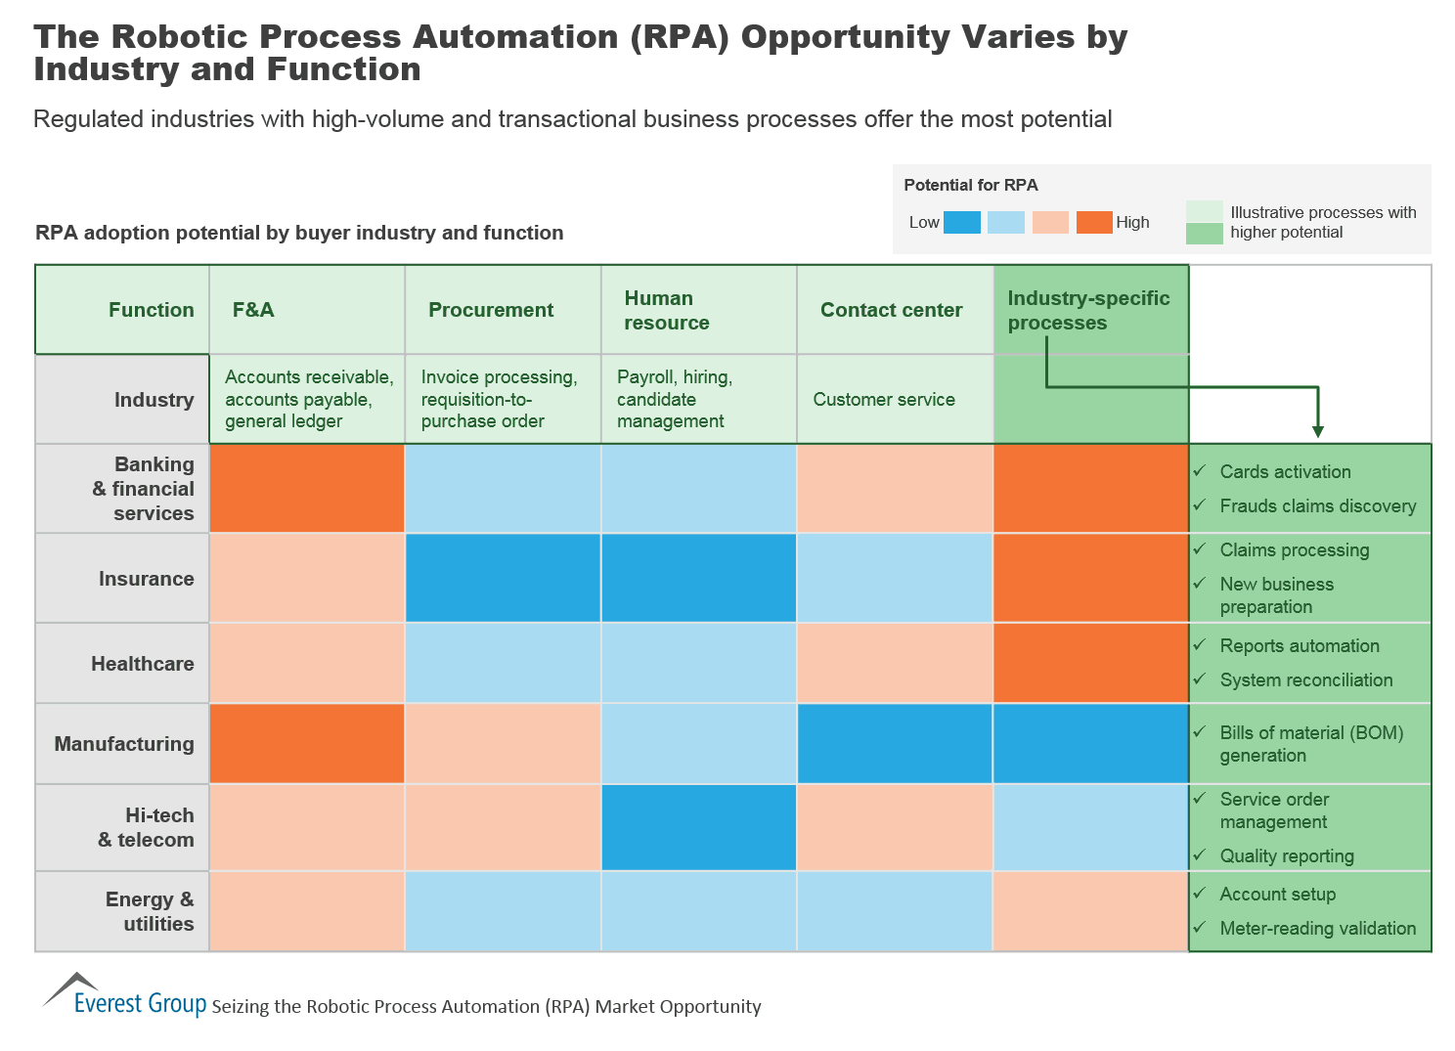

## Robotic Process Automation tools

Selection of RPA Tool should be based on following 4 parameters:

1. **Data**: Easy of reading and writing business data into multiple systems
2. **Type of Tasks mainly performed**: Ease of configuring rules-based or knowledge-based processes.
3. **Interoperability**: Tools should work across multiple applications
4. **AI**: Built-in AI support to mimic human users

**RPA Platforms**

The burgeoning RPA vendor market has been showing continual and steady growth. While the largest market is the US, followed by the UK, the market in Asia Pacific Countries (APAC) is also showing considerable progress. Successful pilot projects and increased customer satisfaction among the early adopters of RPA will encourage new players to adopt this technology. There is growing demand for RPA, especially in industries that need largescale deployments. The major markets for RPA are banking and finance, healthcare and pharmaceuticals, telecom and media, and retail. A few key vendors, their client market, and company specifications are mentioned in the following sections.

**Automation Anywhere:** Automation Anywhere helps to automate business processes for companies. They focus on RPA, cognitive data (machine learning and natural language processing), and business analytics. Their bots are capable of handling both structured as well as unstructured data. The system has three basic components:

* 1. A development client for the creation of a bot.
  2. A runtime environment for the deployment of a bot.
  3. 3. A centralized command system for handling multiple bots, analyzing their performance: *HQ: San Jose, California, USA

*Est: 2003 CEO: Mihir Shukla

*Some key clients: Deloitte, Accenture, AT&T, GM, J P Morgan Chase

*Source of revenue by region: Its highest source of revenue is the USA, which accounts for more than half its revenue, followed by APAC, then UK and continental Europe

*Source of revenue by industry: The Banking, Financial services, and Insurance (BFSI) accounts for more than half of its revenue, followed by healthcare, telecom, media, and others. 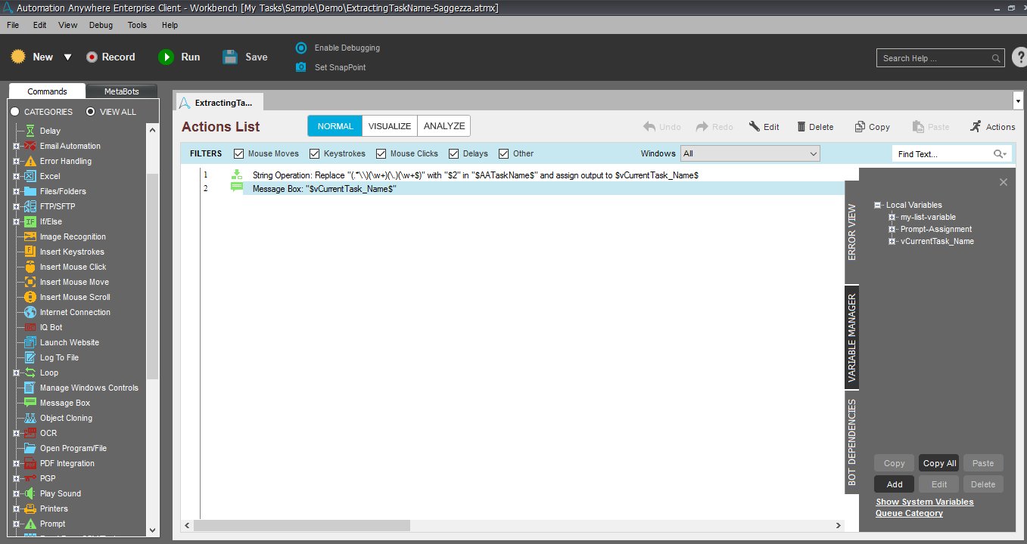

## UiPath: UiPath is an RPA technology vendor who designs and delivers software that helps automate businesses. The RPA platform consists of three parts:

## UiPath Studio to design the processes

## UiPath Robot to automate tasks designed in UiPath Studio

* UiPath Orchestrator to run and manage the processes:

*HQ: Bucharest, Romania.

*CEO: Daniel Dines.

*Some key clients: Atos, AXA, BBC, Capgemini, CenturyLink, Cognizant, Middlesea, OpusCapita, and SAP.

*Source of revenue by region: North America, Continental Europe, the UK, and APAC

*Source of revenue by industry: BFSI, healthcare, telecom and media, and retail.

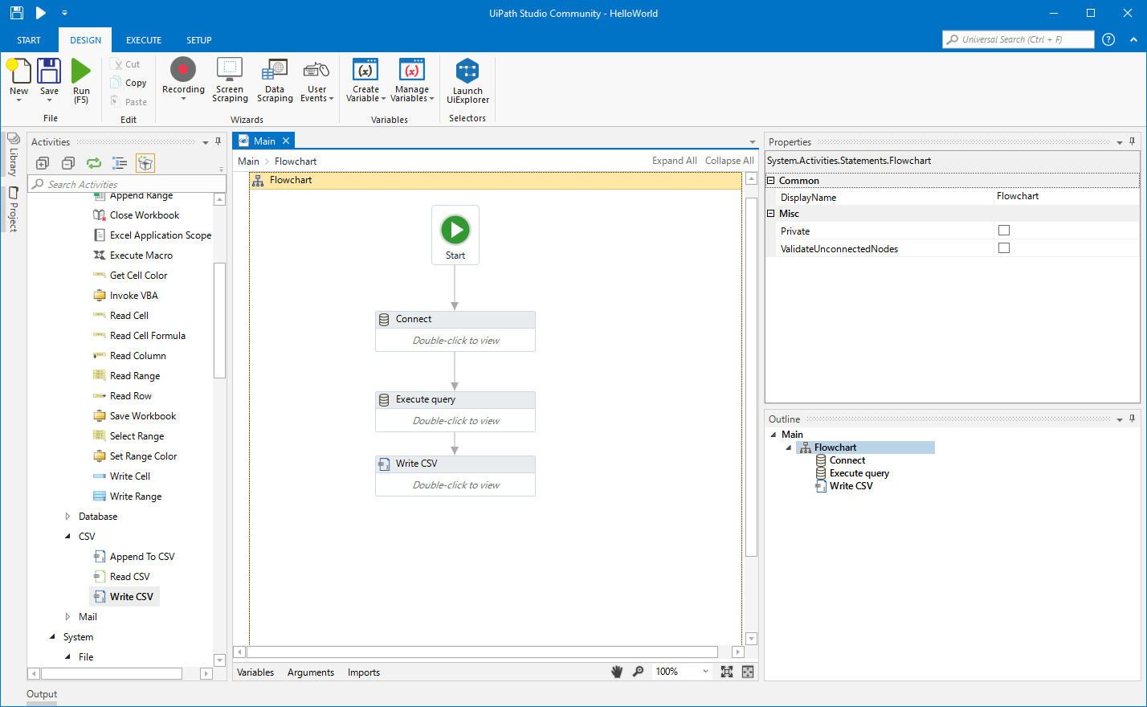

## Blue Prism: Blue Prism aims to provide automation that enterprises can use according to their needs. Blue Prism aims to do this by providing automation that is scalable, configurable, and centrally managed. It sells its software through its partners, some of which are Accenture, Capgemini, Deloitte, Digital Workforce Nordic, HPE, HCL, IBM, TCS, Tech Mahindra, Thoughtonomy, and Wipro:

*HQ: United Kingdom

*Est: 2001 CEO: Alastair Bathgate

*Some key clients: BNY Mellon, RWE npower, and Telefonica O2.

*Source of revenue by region: More than half of its revenue source comes from the UK, followed by North America, Continental Europe, and APAC.

*Source of revenue by industry: BFSI, health, and pharmaceuticals, retail and consumer, telecom and media, manufacturing, public sector, travel, and transportation.

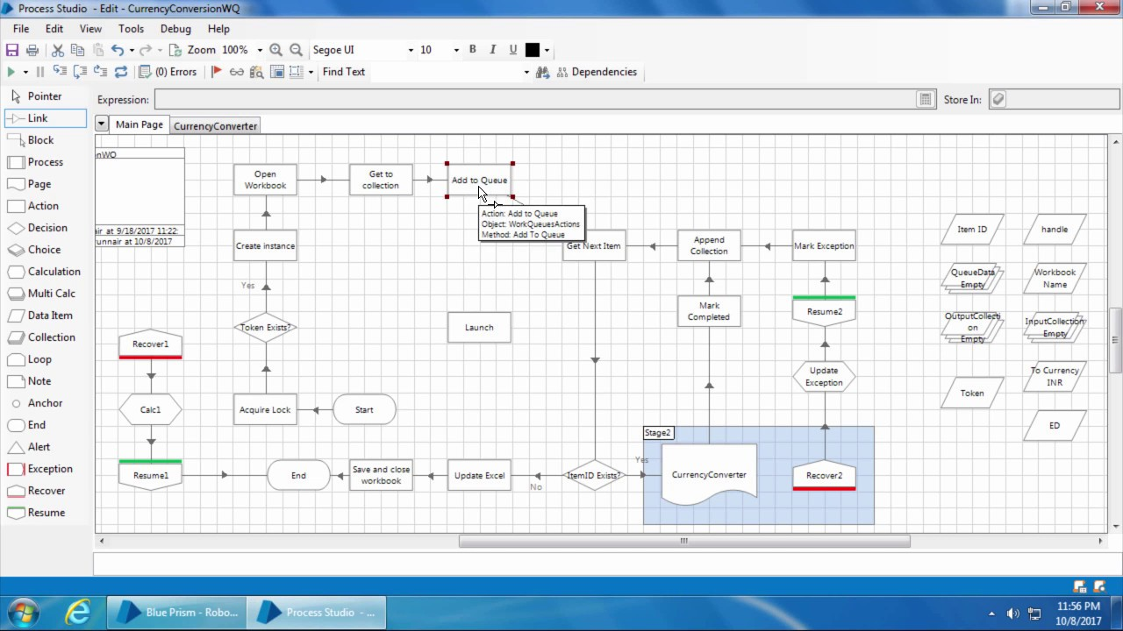

## WorkFusion: WorkFusion offers automation that is based on RPA and machine learning. It delivers software as a solution for automating high volume data. WorkFusion enables man and machine to work in tandem while managing, optimizing, or automating tasks:

*HQ: New York, USA

*Est: 2011 CEO: Max Yangkelivich, Andrew Volkov

*Some key clients: Thomson Reuters, Infogroup, Citi, and Standard Bank.

*Source of revenue by region: North America provides more than 80% of WorkFusion's revenue, followed by Europe, APAC, and MEA.

*Source of revenue by industry: Around 90% of its revenue comes from the BFSI sector, followed by the retail and consumer sectors.

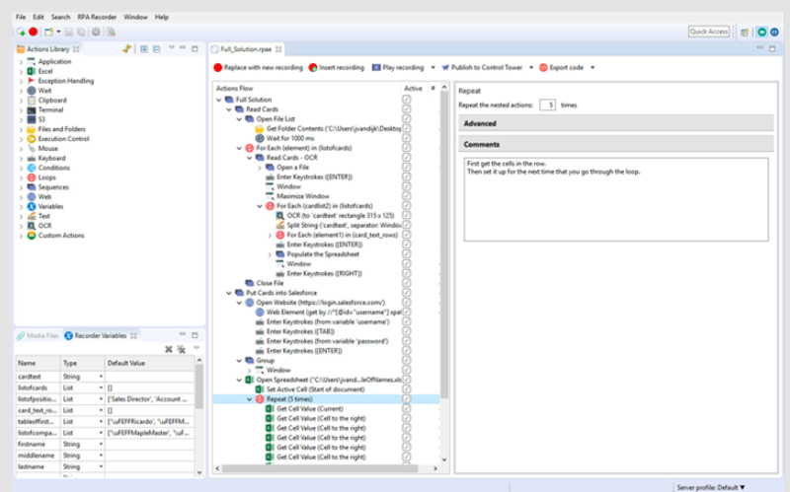

## Seeing the Value in RPA

## Customer satisfaction: By freeing up your customer-service personnel from forms and tabulations, you’re making them all the more available for attentive customer service. You’re also reducing the opportunity for errors. The result is an increase in customer satisfaction and much greater ability to meet the requirements of service-level agreements.

## Productivity: Compared with humans, software robots have been clocked completing the same tasks about five times faster. They also work 24/7 and don’t ask for time off, don’t eat lunch, or don’t visit the restroom. Beyond that obvious increase in productivity related to those tasks, you’ve also freed employees for unstructured problem-solving. You’re increasing their satisfaction and efficiency, and that boosts productivity even further.

## Accuracy: Face it . . . humans make mistakes. Robots are 100 percent accurate, 100 percent consistent, and 100 percent compliant with policies. The more you turn over to robots, the fewer clerical errors you experience, and the more time you save that used to be spent correcting those errors. » Resource utilization: Offloading the mundane tasks to robots frees up your team to handle the tasks that add the most value to your business. What’s more, after you’ve turned a portfolio of tasks over to a robotic workforce, you’re more able to respond to a spike in demand or a lull. That’s good for customer service and helps ease HR headaches.

## Return on investment (ROI): All kinds of improvements can yield positive ROI, including both technological advancements and upgrades in your human workforce. What’s notable about your robotic workforce, after you flip the switch, is that your ROI shows up with lightning speed. Your operating costs will drop quickly, and everyone likes ROI that doesn’t take forever to show up on the bottom line.

**Disadvantages of RPA:**

Let's not forget some cons of the RPA process:

1. The bot is limited to the speed of the application
2. Even small changes made in the automation application will need the robots to be reconfigured.

**UiPath**

Headquartered in Bucharest, UiPath is an RPA vendor that provides software to help organizations automate their business processes. The company aims to do away with repetitive and tedious tasks, allowing humans to engage in more creative and inspiring activities. UiPath was founded by Daniel Dines, who is the CEO. It has offices in London, Bucharest, Tokyo, Paris, Singapore, Melbourne, Hong Kong, and Bengaluru. With clients spread across the world, from North America to the United Kingdom, Continental Europe to Asia Pacific countries, the company has shown remarkable growth in the last year, both in terms of revenue and its workforce. Today, its software is being widely used to automate business processes. However, the IT sector is also gradually embracing UiPath's software. Major clients of UiPath in the industry include BFSI, Telecom and media, healthcare, retail and consumer, and manufacturing. With UiPath automation software, one can configure software Robots to mimic human action on the user interface of computer systems. The basic components of the UiPath RPA platform are in line with what was explained in Components of RPA, these components are necessary for enterprise deployment. The components of the UiPath platform are UiPath Studio, UiPath Robot, and UiPath Orchestrator, see the following sections.

**UiPath Studio**

UiPath Studio helps users with no coding skills to design Robotic processes in a visual interface. It is a flowchart-based modeling tool. Thus, automation is faster and more convenient. Multiple people can contribute to the same workflow. The presence of a visual signal that points out errors in the model, and a recorder that performs what the user executes, make modeling much easier. UiPath Studio is the development environment of UiPath. It is the primary tool to develop UiPath Robots. It can be used to configure steps of a task or launch a full recorder to record a sequence of steps. The recording facility in the Studio is a game-changing feature for RPA tools. Its simplicity lets even nontechnical business users design/record steps of a process. This studio lets the user configure Robots, that is, develop steps to perform tasks visually. Most of the configuration and coding in UiPath is visual. By using the drag-drop facility from the toolbox, you may write a whole sequence of workflows to perform a set of tasks by Robots. These steps look like a data flow diagram and are very easy to understand. It is one of the simplest visual flow diagramming tools. Most of the time, in an enterprise environment you will receive process maps to understand the flow of work, which you will use to develop Robots. The studio gives the same look and feel as a workflow. The designer gives you full control of the execution order and actions taken, also known as activities. An activity or action includes clicking a button, writing and reading a file, and so on.

**UiPath Robot**

UiPath Robot runs the processes designed in UiPath Studio. It works in both attended (working only on human trigger) and unattended environments (self-trigger and work on their own). UiPath Robot is a Windows service that can open interactive/non-interactive window sessions to execute processes or a set of steps, developed or recorded using UiPath Studio. Sometimes, it is also called an execution agent as it executes automation projects, or a runtime agent as it executes instructions generated by developing or recording processes in UiPath Studio. The most acceptable nomenclature is Robot. These Robots can be controlled by Orchestrator, which is part of the Enterprise Edition. There is an option at installation to de-link these Robots from Orchestrator and work independently on the desktop. In most of our examples, we will refer to the Community Edition, which does not have Orchestrator, and the installed Robot will work independently in user mode. When installed in user mode, these Robots have the exact same rights as the user. If you opted for Orchestrator, you can control Robots irrespective of whether it is installed on a user machine, in user mode, or on a server.

**Types of Robots:**

The following are types of Robots:

**Attended:** It operates on the same workstation as a human to help the user accomplish daily tasks. It is usually triggered by user events. You cannot start a process from Orchestrator on these types of Robots, and they cannot run under a locked screen.

**Unattended:** It can run unattended in virtual environments and can automate any number of processes. In addition to the Attended Robot's capabilities, this Robot is responsible for remote execution, monitoring, scheduling, and providing support for work queues.

**Free:** It is similar to Unattended Robots, but can be used only for development and testing purposes, not in a production environment.

**UiPath Orchestrator**

UiPath Orchestrator is a web-based platform that runs and manages Robots. It is capable of deploying multiple Robots, and monitoring and inspecting their activities. UiPath Orchestrator is a server-based application that lets you orchestrate your Robots, hence the name Orchestrator. It runs on a server and connects to all the Robots within the network, whether Attended, Unattended, or Free. It has a browser-based interface that enables the orchestration and management of hundreds of Robots with a click. Orchestrator lets you manage the creation, monitoring, and deployment of resources in your environment, acting in the same way as an integration point with third-party applications.

**Orchestrator's main capabilities:**

* It helps in creating and maintaining the connection between Robots.
* It ensures the correct delivery of the packages to Robots.
* It helps in managing the queues It helps in keeping track of the Robot identification
* It stores and indexes the logs to SQL or Elasticsearch

Behind the scenes, Orchestrator Server uses: IIS Server SQL Server Elasticsearch Kibana.

Figure - UiPath Studio

**RPA EMAIL AUTOMATION**

This is a basic application of Robotic Process Automation (RPA). The user just needs to provide their login credentials and the user email they want to send the email and that is it, rest of the work will be done by the bot that we are going to create using the steps mentioned below –

**Note :** For this automation to work you need to enable access from *Less Secure apps* on your Gmail account.

**Step-1 :** Create a new process in Uipath Studio by clicking on the ***Process Tab****.*

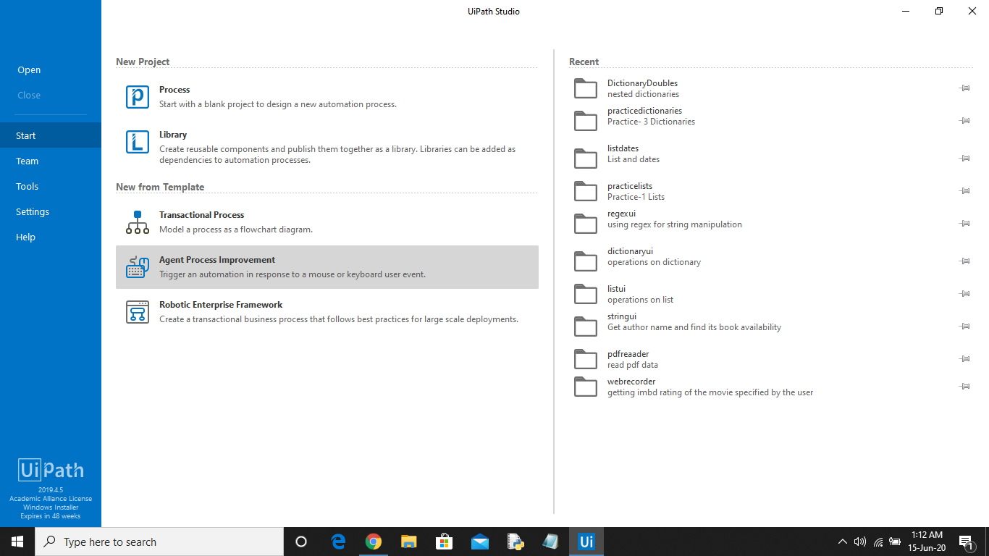

**Step-2 :** Set the name of the process, give a brief description, and click on ***Create***. The Uipath studio will automatically load and add all the dependencies of the project.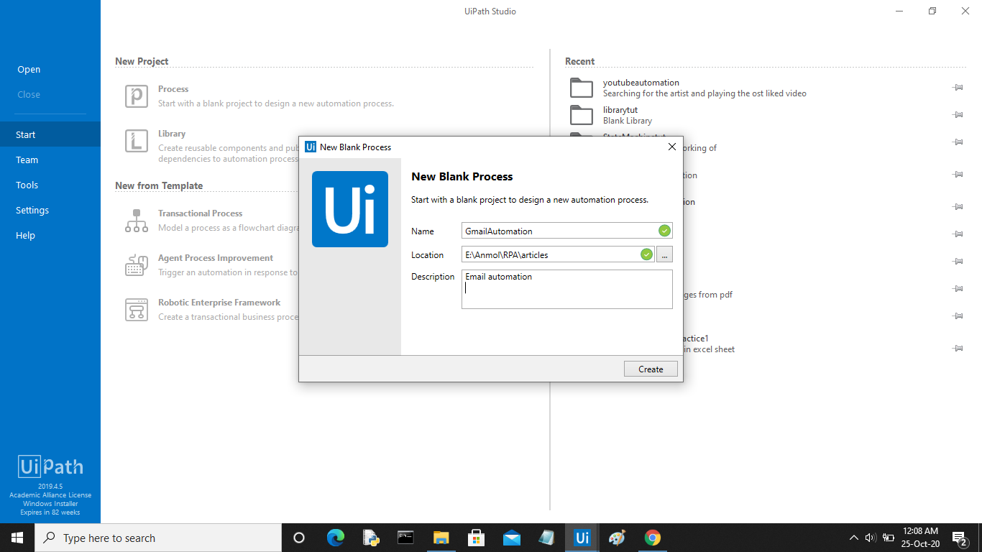

The following screen will be opened.

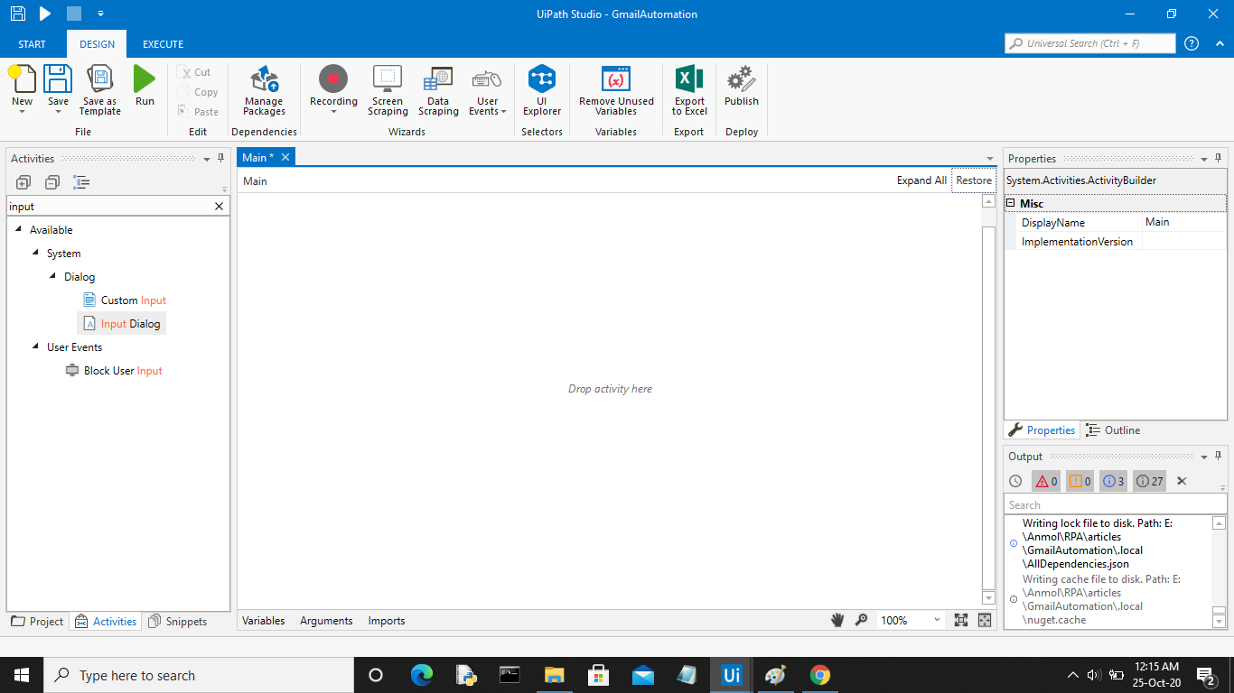

**Step-3 :** Now in the activities panel search for ***Sequence*** activity. Drag and drop it in the designer window.

**Step-4 :** Now in the sequence add an***Input dialog box*** using the search activity panel.

**Step-5 :** Now click on the ***Variables*** tab to create a variable of string type that will store the personal email id entered by the user. In the properties panel of the Input Dialog activity add the variable in the***Output area***.

Create two more string variables, one for storing the password of the user and the second for storing the recipient email id.

**Step-6 :** Now add another *Input dialog box* and pass the variable created earlier to store the password in the ***Output Area*** of the properties panel. Click the checkbox ***IsPassword*** for this activity.

**Step-7 :** Finally add another ***Input dialog box*** for taking the recipient email id from the user. Pass the variable created earlier in the ***Output Area***.

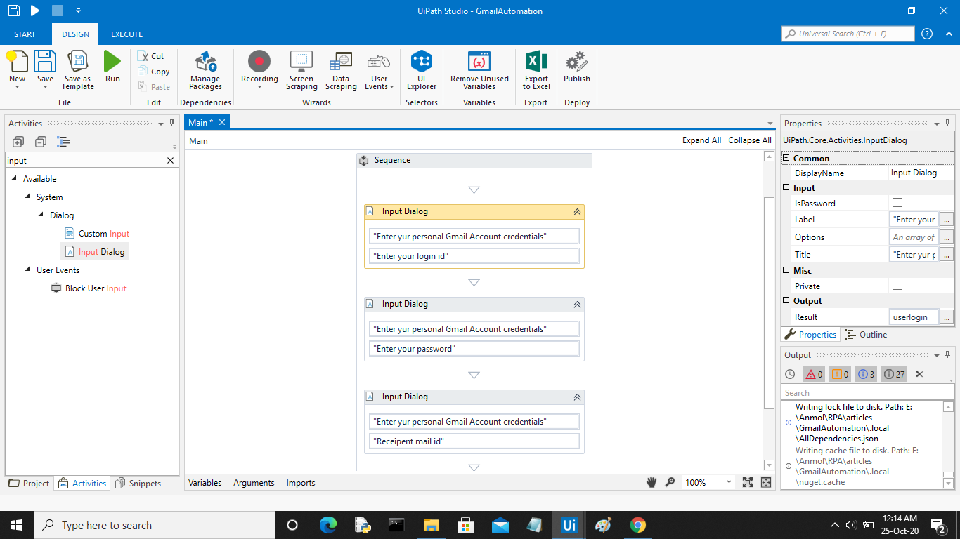

**Step-8 :** Now in the ***Activity Panel*** search for ***Send SMTP Mail Message*** activity. Drag and drop it to the sequence.

**Step-9 :** In the ***To*** field pass the variable that stores the recipient email id. Specify the ***subject*** and***body***of the mail.

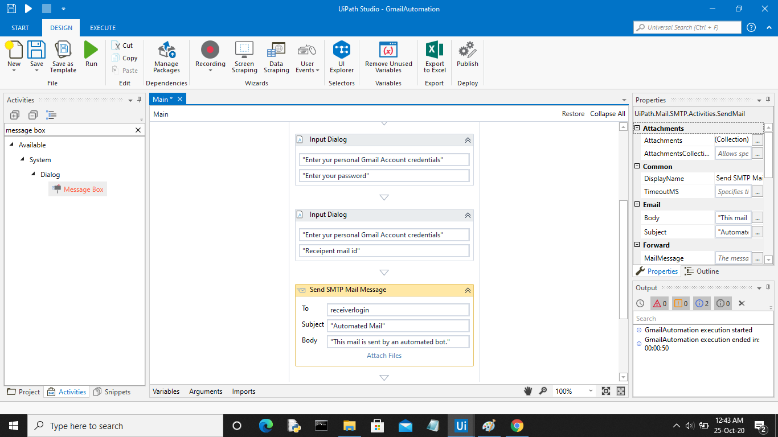

**Step-10 :** In the ***Properties* *panel*,** set *Port no.* to ***587*** and *Server* to ***smtp.gmail.com***. Pass the variables that store user credentials in the email and password field respectively.

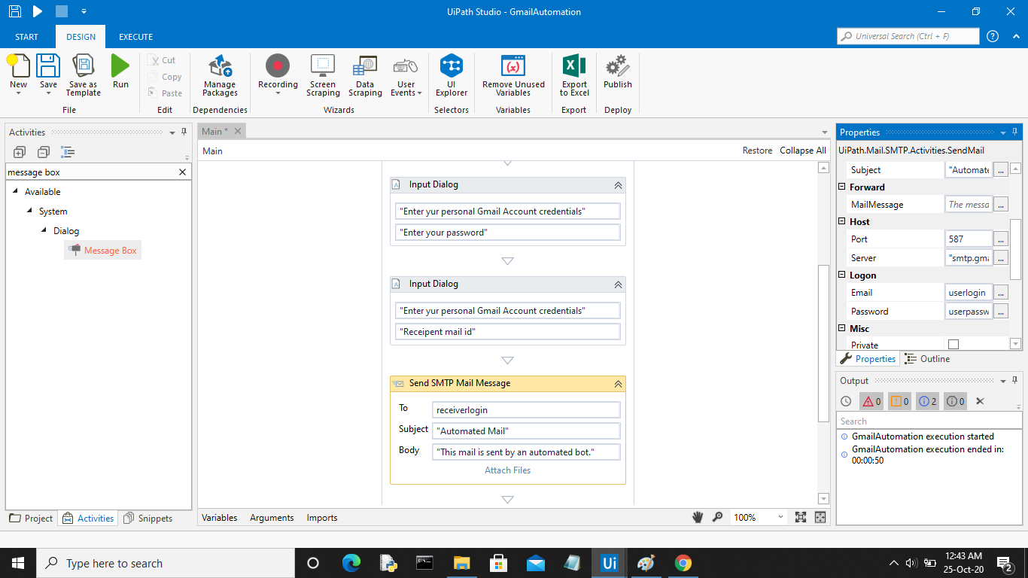

**Step-11 :** Finally add a***Message Box*** activity. Specify the message you want to display as a notification that the email was sent successfully.

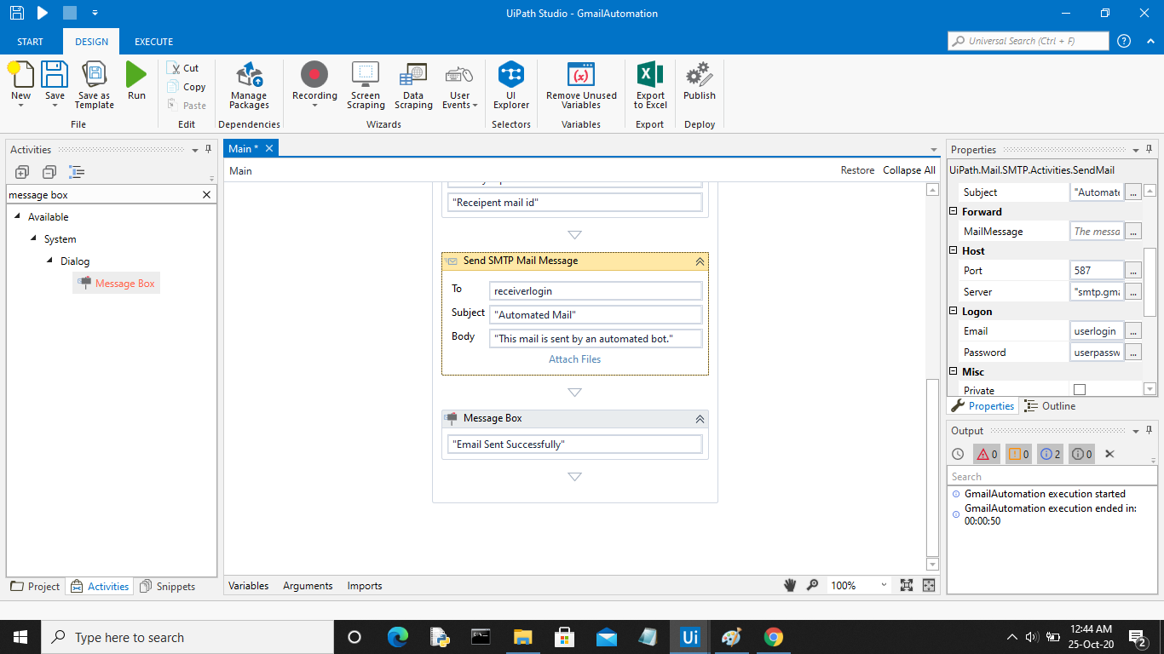

**Step-12 :** Save the process using the ***Save*** button in the design panel and then click on ***Run***. Your bot is ready for sending automated emails. The below video shows the working of the bot.

**ARCHITECTURE OF THE SYSTEM**

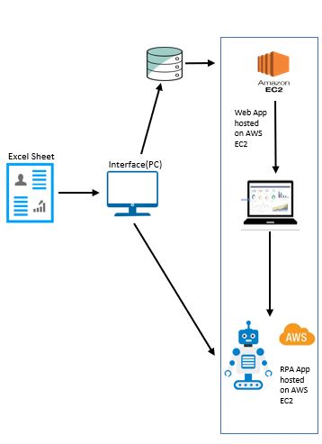

**Architecture diagram**

**INTERACTION MODEL**

Interaction model helps us understand how the user will interact with the system. As we know that our system will require the user to interact with the webpage and their interaction will take place as follows:

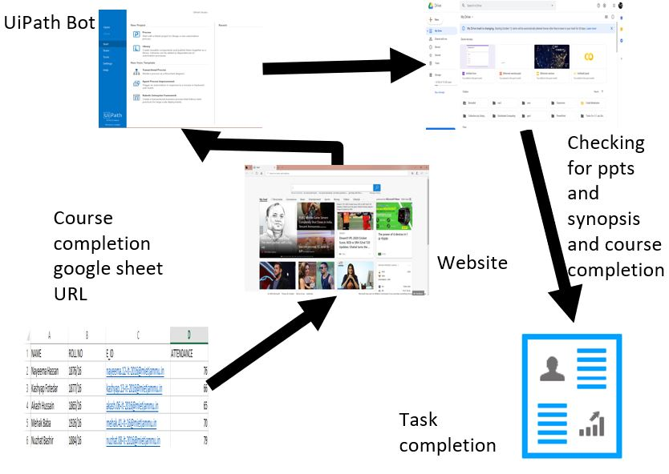

**Results:**

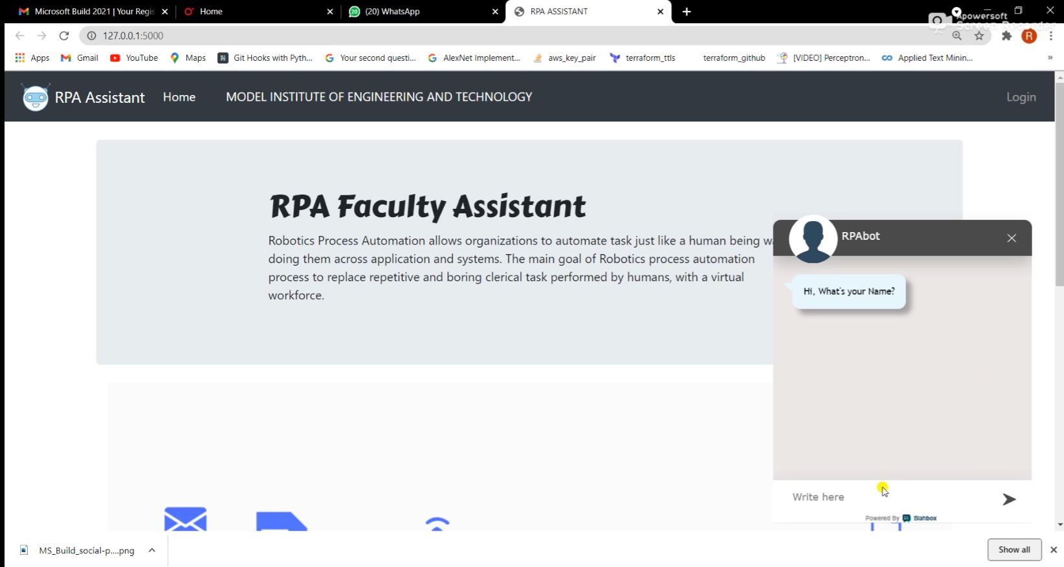

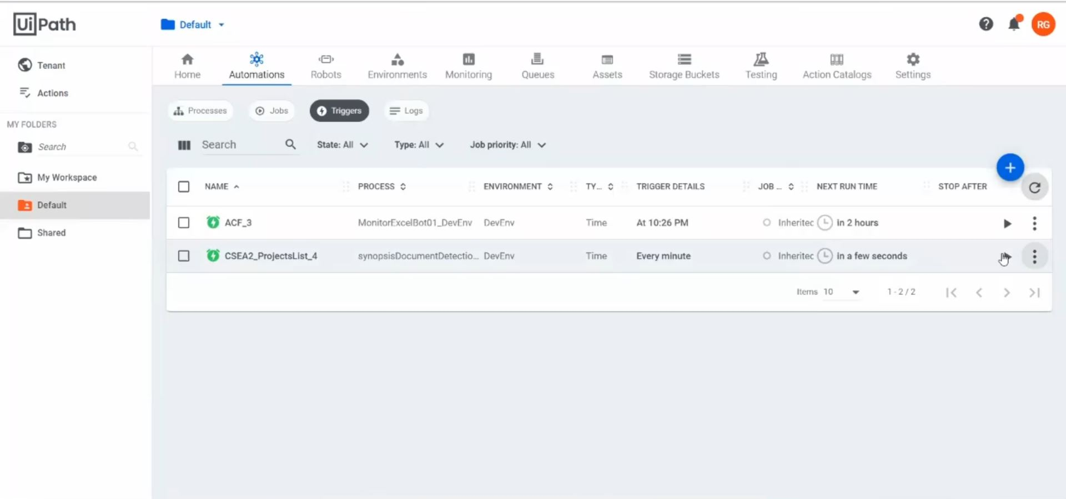

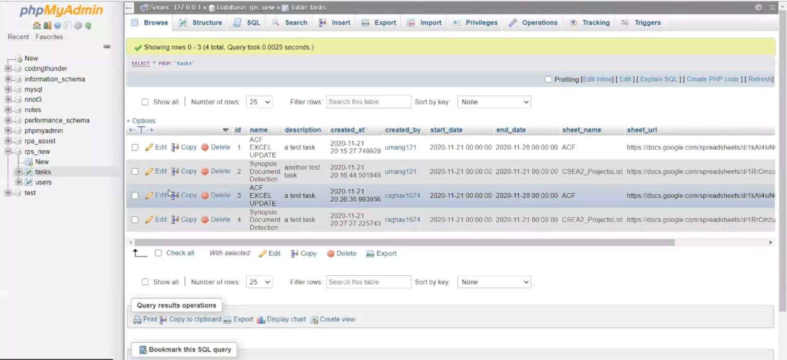

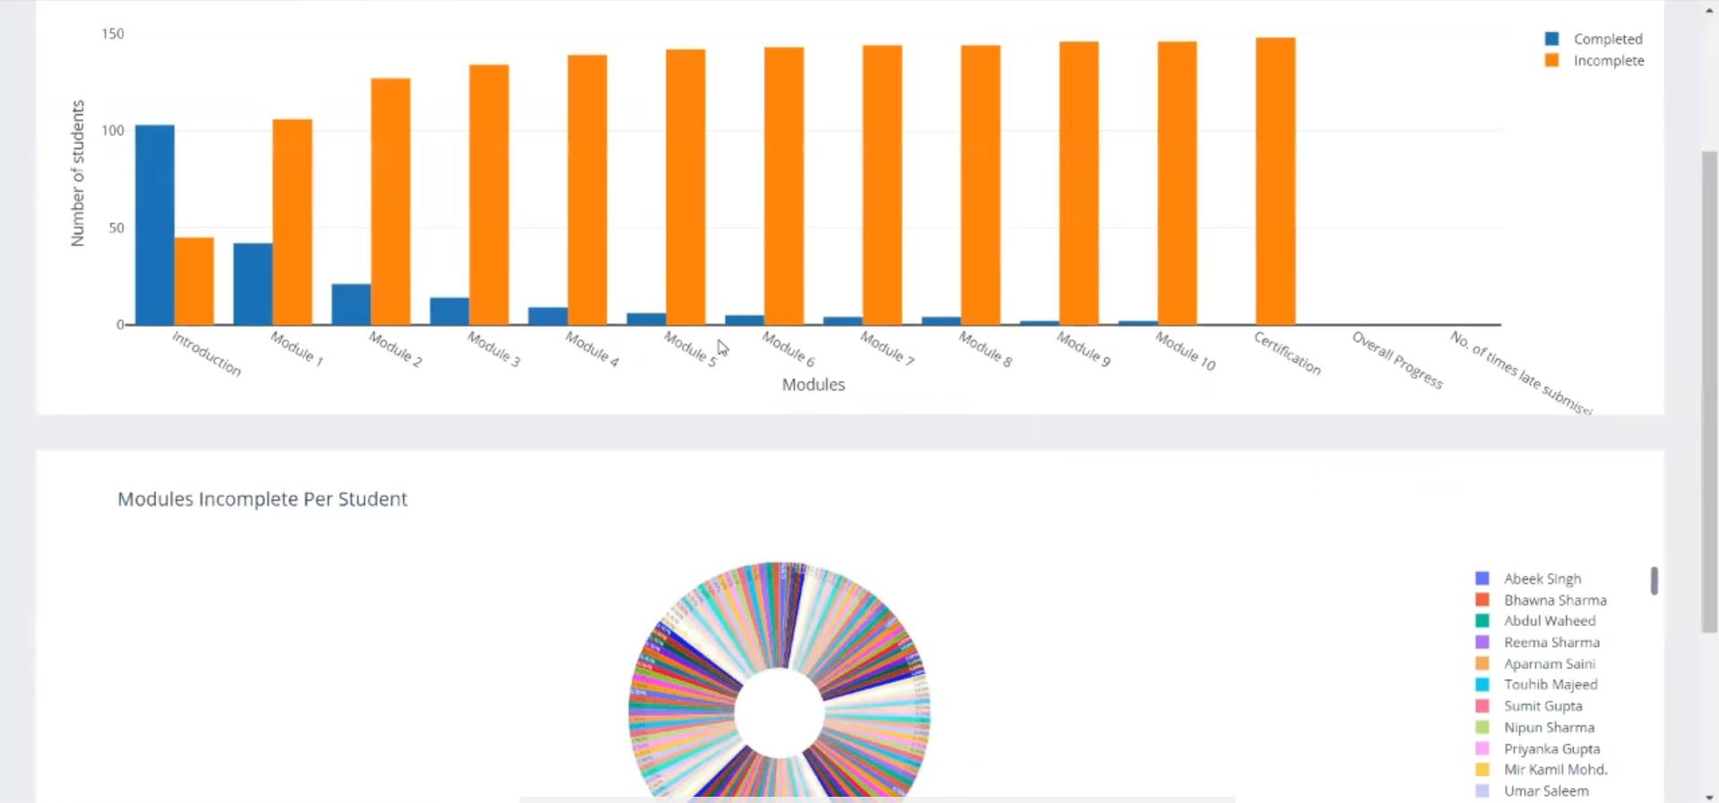

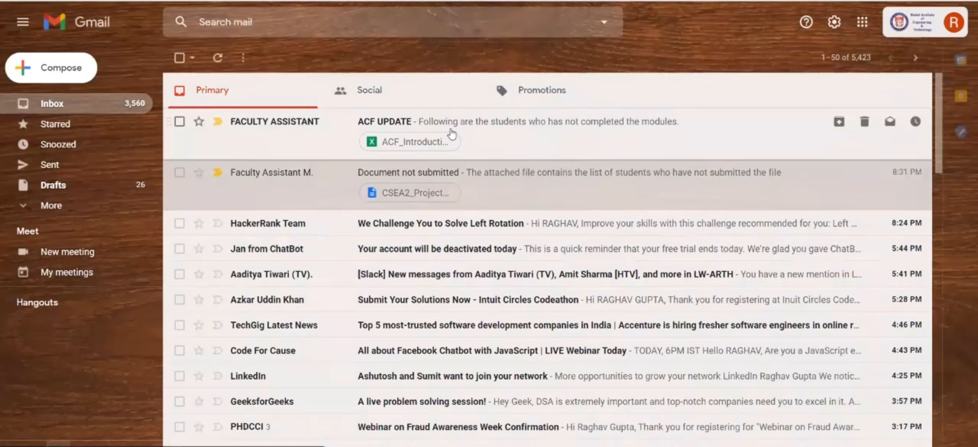

**REFERENCES**

* 1. <https://docs.uipath.com/studio/docs/about-data-scraping>
  2. http://www.ir.juit.ac.in:8080/jspui/bitstream/123456789/22756/1/RPA%20AUTOMATION%20ANYWHERE.pdf
  3. <https://en.wikipedia.org/wiki/Robotic_process_automation>
  4. <https://en.wikipedia.org/wiki/UiPath>